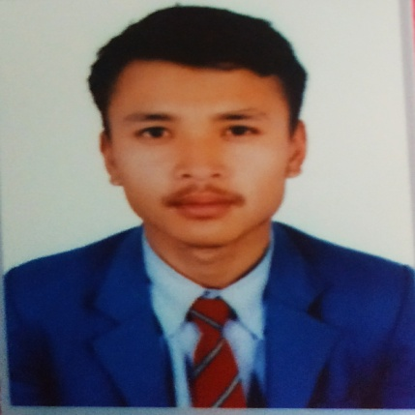

* **Participate in many voluntary works and rally organised by Nepal Scout.**
* **Became first in football tournament oragnised by Godawari Municipality.**
* **Certified with certificate of excellence from HOD of Mathematics of Laligurans English Secondary School.**

**Web Designing**

**Aptech Institution ( 3 months)**

**Mark Obtained : A**

**Laligurans English Secondary School**

**Secondary Education Examination ( 2016 A.D. )**

**Mark Secured : A+**

**DAV College**

**National Examination Board ( 2017-2019 A.D. )**

**Mark Secured: B+**

**I am eminent , extrovert and hardworing fresher student. I had achieved many rewards and secured excellence result in academies.**

**Date of birth: 12November 2001**

**Nationality: Nepali**

**Father’s name: Shree Gopal Maharjan**

**Mother’s name: Nanda Devi Maharjan**

**Languages: Newari, Nepali, Hindi, English**

**Religion: Hinduism**

**QUALIFICATION AND EXTRA CURRICULUM ACTIVITIES**

**EDUCATION**

**Reading**

**Music**

**🖳**

**Programming**

**🎧**

**🖹**

**Travel**

**www.mitchlucker369.com**

**Badegaun, Lalitpur, Nepal**

**+977-9869105302**

**maharjansanish204@gmail.com**

**🖂**

**🌏**

**🕿**🕿

**🏠**

**✈**

**HOBBIES**

**CONTACT**

**PROFILE**

**SANISH MAHARJAN**

**CURRICULUM VITAE**